Each individual kit is packaged in a bag as shown below:

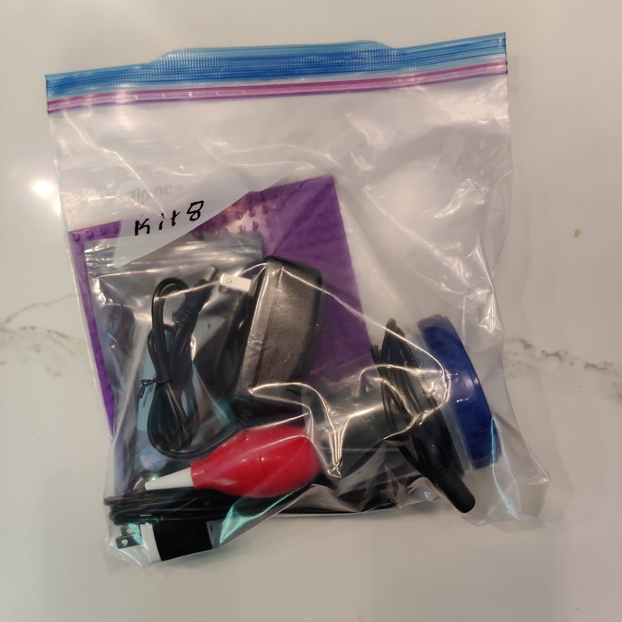

The kit contains seven items:

1. Usb wall socket
2. Usb cable
3. Microcontroller package
4. brick plate

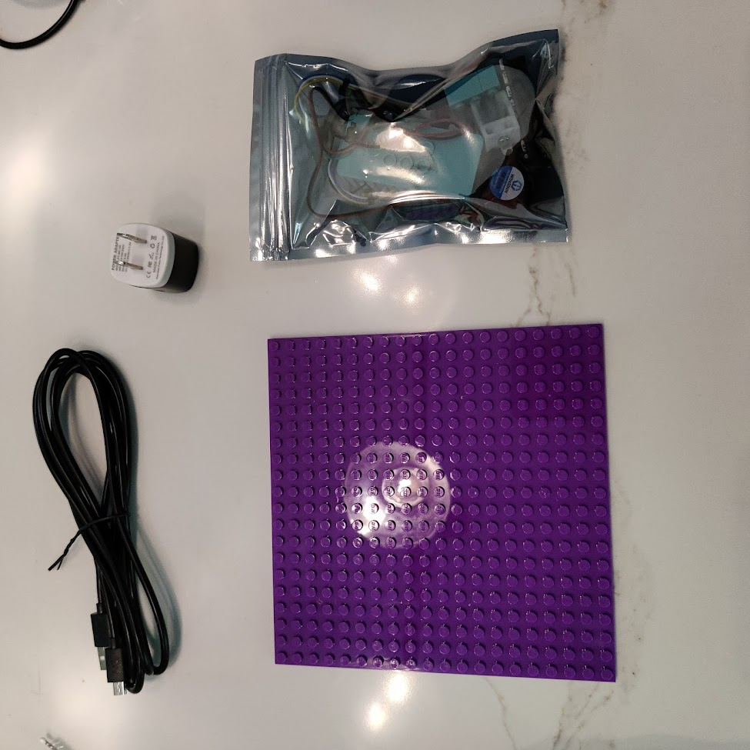

1. Mist generator and enclosure
2. Mist generator wall socket
3. Mist generator pump

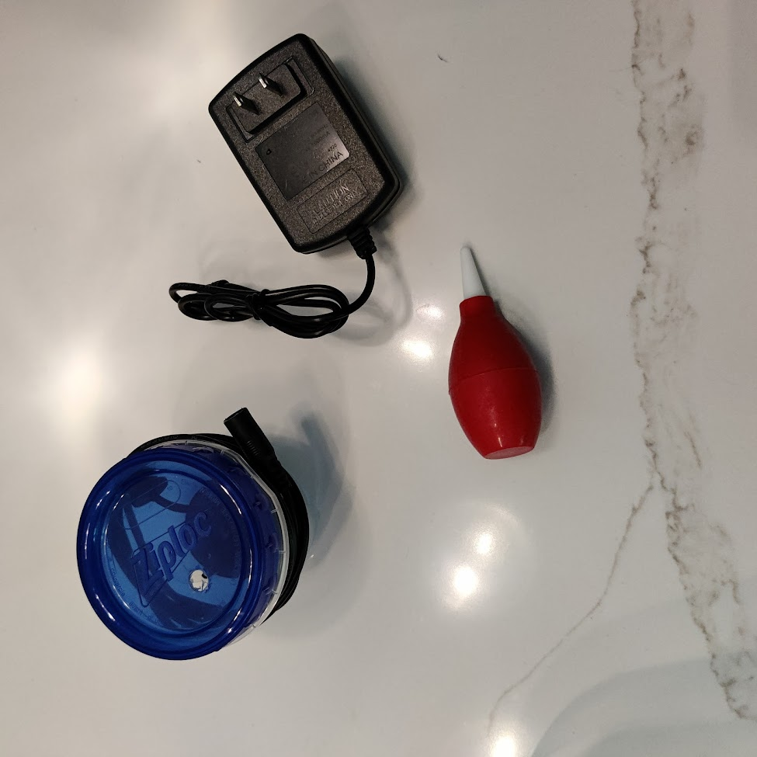

# Mist Generator Assembly

*Note: This assembly could be incorporated into the camper program if desired. Filling the water, plugging in the sensor, and assembling the sensor is a pretty simple task.*

1. Unscrew the lid of the mist generator and take out the red pump and white nozzle.
2. Put the white nozzle into the side of the red pump. Make sure that the tapered end of the nozzle is pointing out.
3. Put the pump assembly into the top of the lid, pushing it in to make a seal.
4. Fill the container with water up to the fill line*, or alternatively about ¼ inch below the hole in the side of the container.
5. Screw in the lid
6. Plug the mist generator into the wall, and squeeze the red pump to produce mist

* Ideally, the water should be 2-3 cm above the top of the mist generator.

** The mist generator has a built-in sensor to determine if there is enough water for the machine to function properly. If the mist generator is lighting up but not producing mist, the generator is detecting insufficient water to create mist. Add more water and try again.

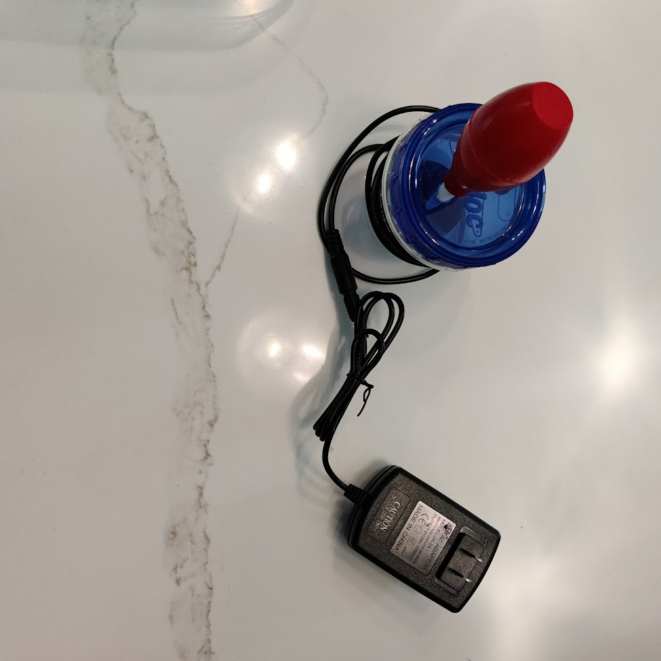

# Air Sensor Assembly

1. Unpack the microcontroller and wire harness from the static-safe bag.

Note: the microcontrollers are not waterproof! Make sure the campers know to be careful with their mist generators and accidentally spilling water on the boards. A little bit of mist will be fine, but water will make the boards break. This problem can be turned into a challenge for the campers to use the lego bricks on the bottom of their enclosure to make sure the microcontroller is far away from the fan.